CUONG ASSIGNED MID-TERM TASKS
My tasks:
- 1.2. Review at least three models, algorithms, or approaches related to the project topic.
- 1.4. Compare the advantages, disadvantages, and applicability of the reviewed models/approaches to the project.
- 2.3. Present the data preparation process, including segmentation, normalization, noise reduction, labeling, and dataset splitting.
- 3.1. Present the architecture or workflow of the proposed solution.

1.2. Review of Related Models and Approaches
- MFCC + CNN:

Audio → Preprocessing → MFCC → CNN → Global Average Pooling → Command

MFCC provides a compact feature representation and serves as an MFCC-based baseline. This is a lightweight and fast approach, but it may lose some detailed time-frequency information.

- Log-Mel + CNN:

Audio → Log-Mel Spectrogram → CNN → Fully Connected Layer → Command

CNN learns local acoustic patterns directly from the Log-Mel spectrogram. It provides a good balance between accuracy, model size, and inference speed for short speech commands.

- CRNN (CNN-GRU):

Audio → Log-Mel Spectrogram → CNN → Reshape to time sequence → 2-Layer GRU → Temporal Mean Pooling → LayerNorm + Dropout + Linear → Command

CNN extracts local spectral features, the GRU models temporal dependencies across the speech frames. CRNN is more suitable for longer or more complex speech sequences, but it requires more computation and training time.

We applied CNN-GRU-based CRNN approach, because it achieves the best and most balanced performance with a test accuracy of 97.46% and a macro-F1 score of 97.14%, outperforming the MFCC-CNN and Log-Mel CNN baselines.

Approach | Results
MFCC + CNN | 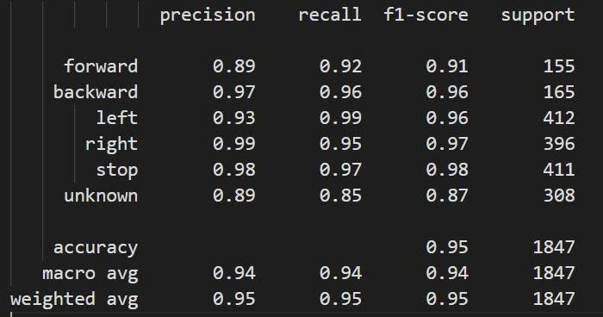
Log-Mel + CNN | 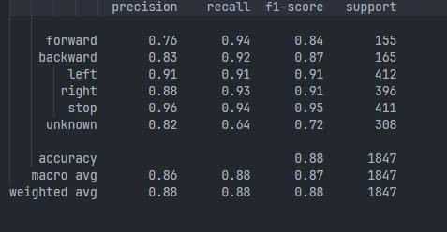
Log-Mel + CRNN (CNN-GRU) | 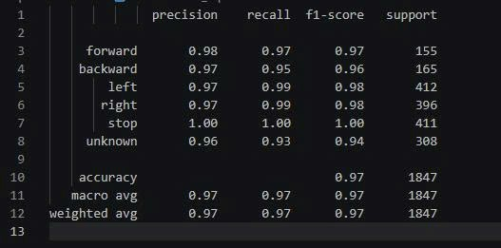

- Codex: Additional content for Section 1.2
- Common preprocessing steps:
- - Load WAV file. Keep waveform as the basic audio signal.
- - Convert stereo audio to mono. One channel only. Less input variation.
- - Resample to 16 kHz. Same sampling rate for all data.
- - Convert each clip to a fixed 1-second segment. Short clips are zero-padded. Long clips are trimmed.
- - Normalize peak amplitude. Reduce volume difference between speakers and microphones.
- - Optional speech alignment. Move the active speech part near the center of the 1-second window.
- - Noise handling. Reduce stationary background noise before feature extraction when needed.
- - Training augmentation only. Add noise, time shift, and gain change. Validation and test data stay clean and unchanged.

- MFCC + CNN additional review:
- - Input feature: MFCC coefficients. Compact representation of the speech spectrum.
- - Preprocessing dependency: stable sampling rate and fixed-length waveform are required before MFCC extraction.
- - Model role: CNN learns local patterns from the MFCC map.
- - Useful as a lightweight baseline. Fast training, small model, simple comparison point.
- - Limitation: MFCC compresses the spectrum. Some fine time-frequency information can be lost.

- Log-Mel + CNN additional review:
- - Input feature: Log-Mel spectrogram. Time axis and frequency axis are both visible.
- - Model role: CNN detects local acoustic shapes, such as energy changes and frequency bands.
- - Suitable for short commands because command clips are fixed-length and word-level.
- - Good baseline for practical deployment. Simple architecture and low inference cost.
- - Limitation: temporal dependencies are modeled only indirectly through convolution and pooling.

- Log-Mel + CNN-GRU additional review:
- - Input feature: Log-Mel spectrogram.
- - CNN part: extracts local time-frequency features.
- - GRU part: reads the remaining frame sequence and models temporal changes.
- - Mean pooling: combines frame-level outputs into one command representation.
- - Suitable when the word has useful temporal structure, such as beginning sound, vowel part, and ending sound.
- - Limitation: more parameters and more computation than CNN baselines.

- In this project, the three approaches are kept for comparison. MFCC + CNN is the compact feature baseline. Log-Mel + CNN is the simple spectrogram baseline. Log-Mel + CNN-GRU is the main sequence-aware model.
1.4. Comparison and Applicability to the Project
Criterion | MFCC + CNN | Log-Mel + CNN | Log-Mel + CNN-GRU CRNN
Feature requirements | Handcrafted MFCC features; compact representation. | Log-Mel spectrogram with clear time-frequency structure. | Log-Mel features followed by convolution and recurrent layers.
Model size | Small, ~ 23.8K parameters | Small, ~ 23.8K parameters | Larger, 370,038 parameters
Training cost | Low and fast to train. | Moderate and practical for the current dataset. | Higher because recurrent layers increase computation.
Inference latency | Low; suitable for limited hardware. | Low; efficient on a CPU for short clips. | Higher than the CNN baselines, but still suitable for real-time CPU inference at ~ 4.84 ms/sample
Advantages | Lightweight, fast to train, and suitable for limited resources. MFCC features are compact and easy to compute. | Simple and practical baseline. Log-Mel preserves clearer time-frequency patterns and works efficiently for short speech commands. | Combines strong local feature extraction with temporal modeling. Better captures sequential information across speech frames.
Disadvantages | MFCC retains less detailed time-frequency information and may limit performance compared with Log-Mel-based models | Temporal dependencies are modeled only indirectly through convolution and pooling | Larger model size, higher training cost, and higher inference cost than the CNN baselines.

Codex: Additional content for Section 1.4
- Feature detail: how much acoustic information the feature keeps.
- Temporal modeling: whether the model can directly model frame order.
- Noise sensitivity: how much the approach depends on clean audio.
- Training cost: time and computation needed to train the model.
- Inference cost: model size and CPU latency during demo.
- Deployment fit: whether the model is simple enough for a wheelchair simulation or embedded setup.
- Safety fit: whether the model output can support confidence thresholding and unknown-command rejection.
- Report fit: whether the approach gives a clear baseline and a clear improvement path.

Suggested interpretation:
- MFCC + CNN: best for lightweight baseline and fast experiments.
- Log-Mel + CNN: best for simple spectrogram-based command recognition.
- Log-Mel + CNN-GRU: best for final selected model because it adds temporal modeling while still keeping inference practical.
2.3. Data Preparation Process
- Dataset used: Google Speech Commands.
- Target classes: forward, backward, left, right, stop, and unknown.
- Process pipeline:
Google Speech Commands
→ Official train/validation/test Subsets
→ Target and Unknown Label Selection
→ Load WAV
→ Mono Conversion
→ Resampling to 16 kHz
→ Padding/Trimming to 1 Second
→ Peak Amplitude Normalization
→ Log-Mel Extraction
→ Model Input
Non-target words are sampled and assigned to the unknown class.
Each audio file is converted to mono, resampled to 16 kHz, and adjusted to 16,000 samples. Short recordings are zero-padded, while long recordings are trimmed.
Main feature is a Log-Mel spectrogram using a 25 ms window, a 10 ms hop, a 400-point FFT, and 64 Mel bands.
We used the official Google Speech Commands training, validation, and test subsets to ensure a fixed and reproducible evaluation. The official subsets also help prevent recordings from the same speaker from appearing in both training and testing.

Codex: Expanded content for Section 2.3
Data preparation pipeline:
Raw audio waveform -> audio loading -> mono conversion -> resampling to 16 kHz -> fixed-length 1-second segmentation -> optional speech alignment -> noise handling -> amplitude normalization -> label mapping -> official split -> training-only augmentation -> feature extraction.

2.3.1. Audio loading and format standardization
- Input files are WAV clips from Google Speech Commands or user recordings.
- Each file is loaded as a waveform tensor.
- Stereo audio is converted to mono by averaging channels.
- All audio is resampled to 16 kHz.
- Purpose: same audio format before any model feature extraction.
- Figure: 01_audio_loading_standardization.png.
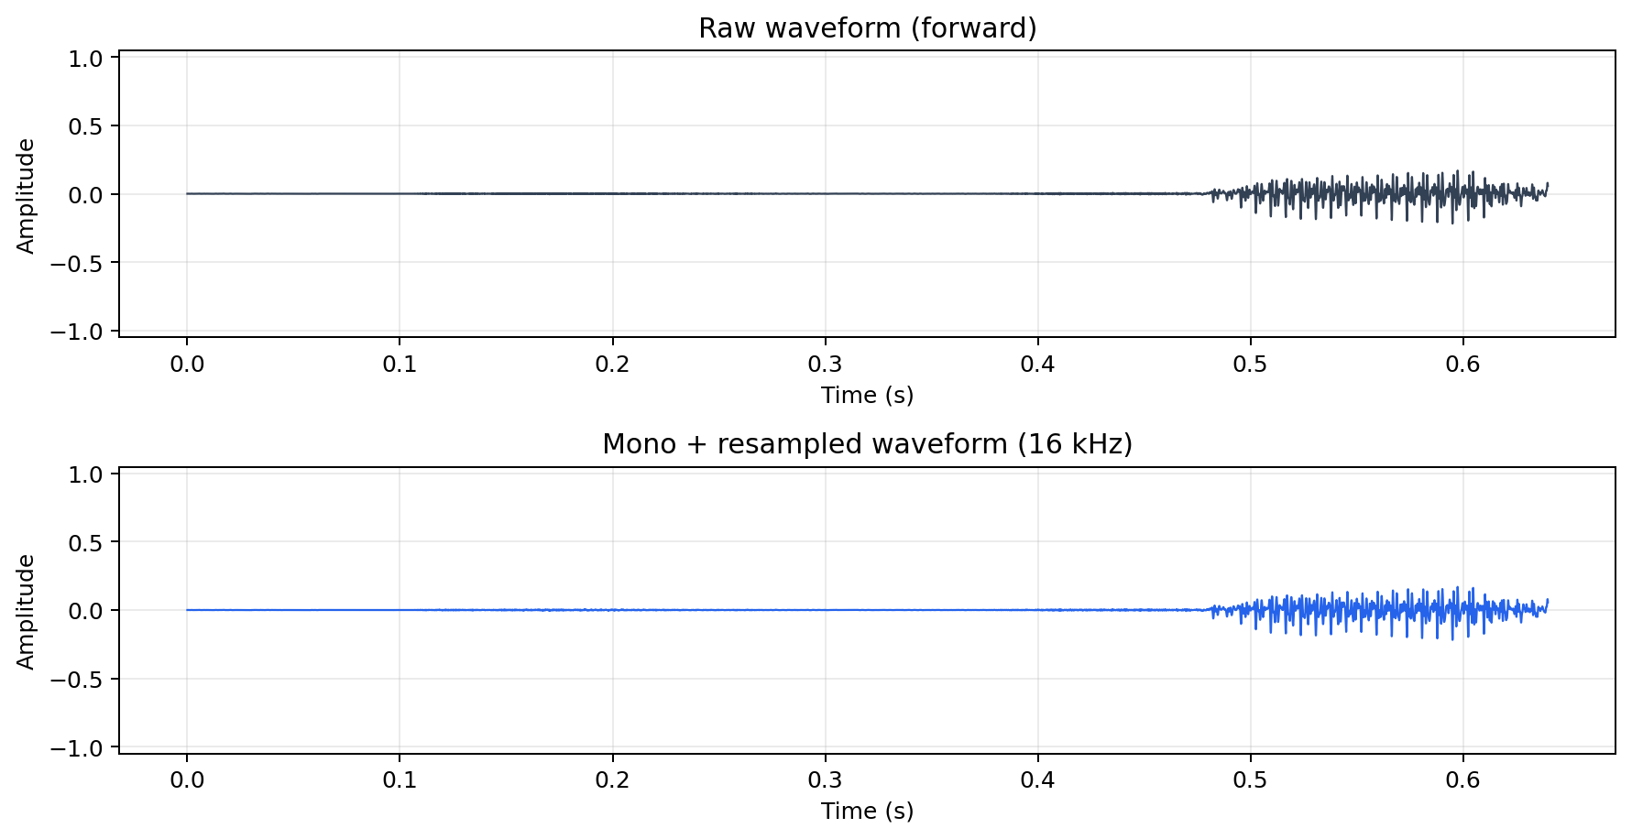

2.3.2. Segmentation and fixed-length windowing
- The command model expects a fixed-size input.
- Each command is converted to 1 second, equal to 16,000 samples at 16 kHz.
- If the recording is shorter than 1 second, zero padding is added.
- If the recording is longer than 1 second, the signal is cropped.
- Speech Commands clips are already word-level clips. Therefore segmentation here means fixed-length command windowing, not sentence-level word segmentation.
- Figure: 02_segmentation_fixed_length.png.
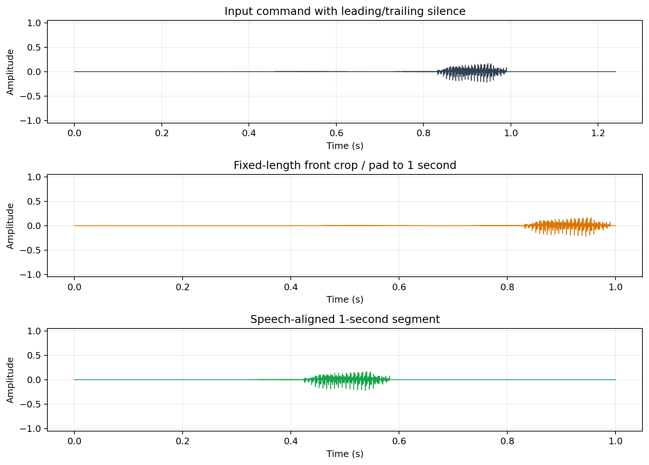

2.3.3. Speech alignment
- Some recordings contain silence before or after the actual word.
- Active speech is estimated from short-frame RMS energy.
- The strongest speech region is centered inside the 1-second window.
- This reduces the case where the important speech part is cut by front cropping.
- Alignment is optional and controlled by config.

2.3.4. Noise handling / noise reduction
- Real microphone input can contain fan noise, room noise, or electrical noise.
- A simple stationary noise reduction step is included.
- The method estimates a low-energy spectral profile and subtracts part of it from the signal spectrum.
- This is basic noise handling, not a separate denoising model.
- Purpose: reduce constant background noise before feature extraction.
- Figures: 03_noise_handling_waveform.png and 04_noise_handling_logmel.png.
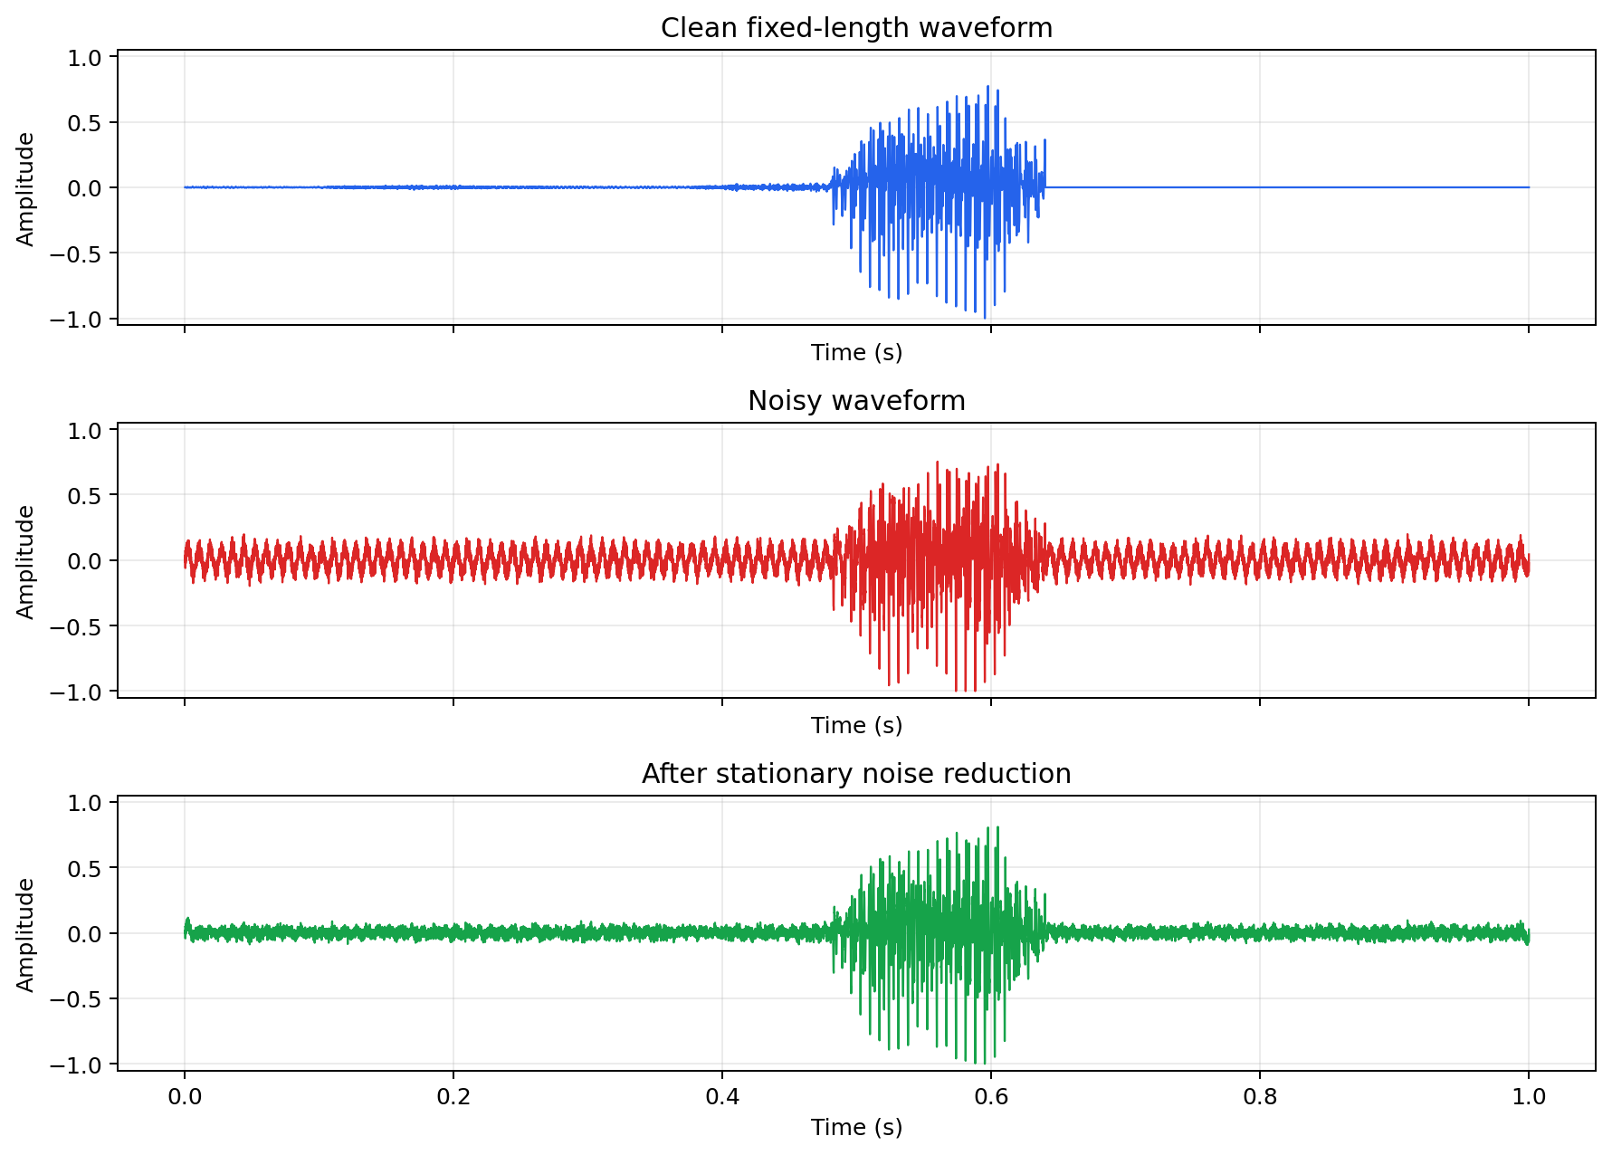
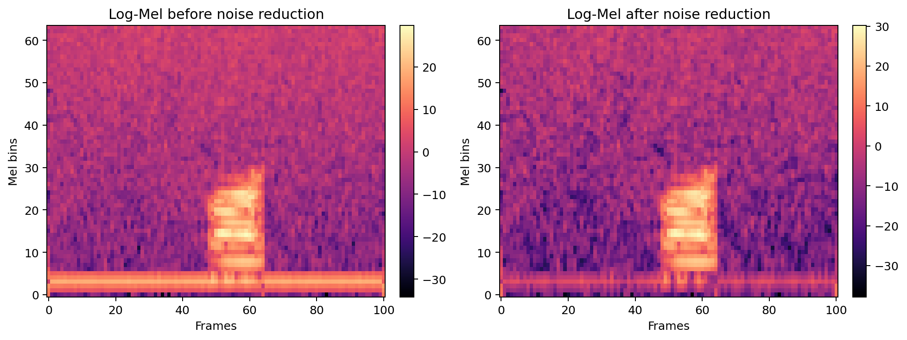

2.3.5. Amplitude normalization
- Different speakers and microphones produce different volume levels.
- Peak amplitude normalization scales the waveform by its maximum absolute value.
- The signal range becomes more consistent across samples.
- This prevents volume from becoming an unwanted dominant factor.
- Figure: 05_amplitude_normalization.png.
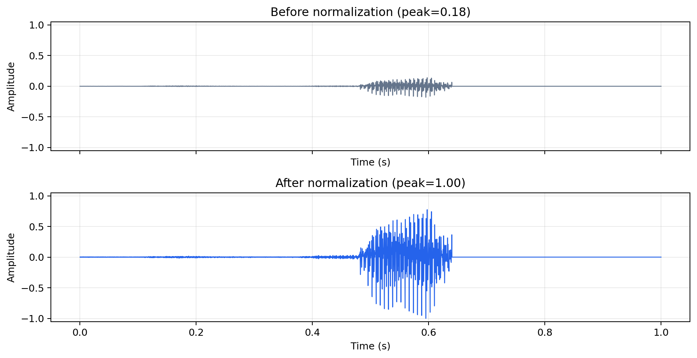

2.3.6. Label mapping and unknown class
- Target commands: forward, backward, left, right, stop.
- Other words are mapped to unknown.
- The unknown class helps the system ignore non-navigation commands.
- The command recognizer therefore has six classes: forward, backward, left, right, stop, unknown.
- Figure: 06_label_mapping_unknown_class.png.
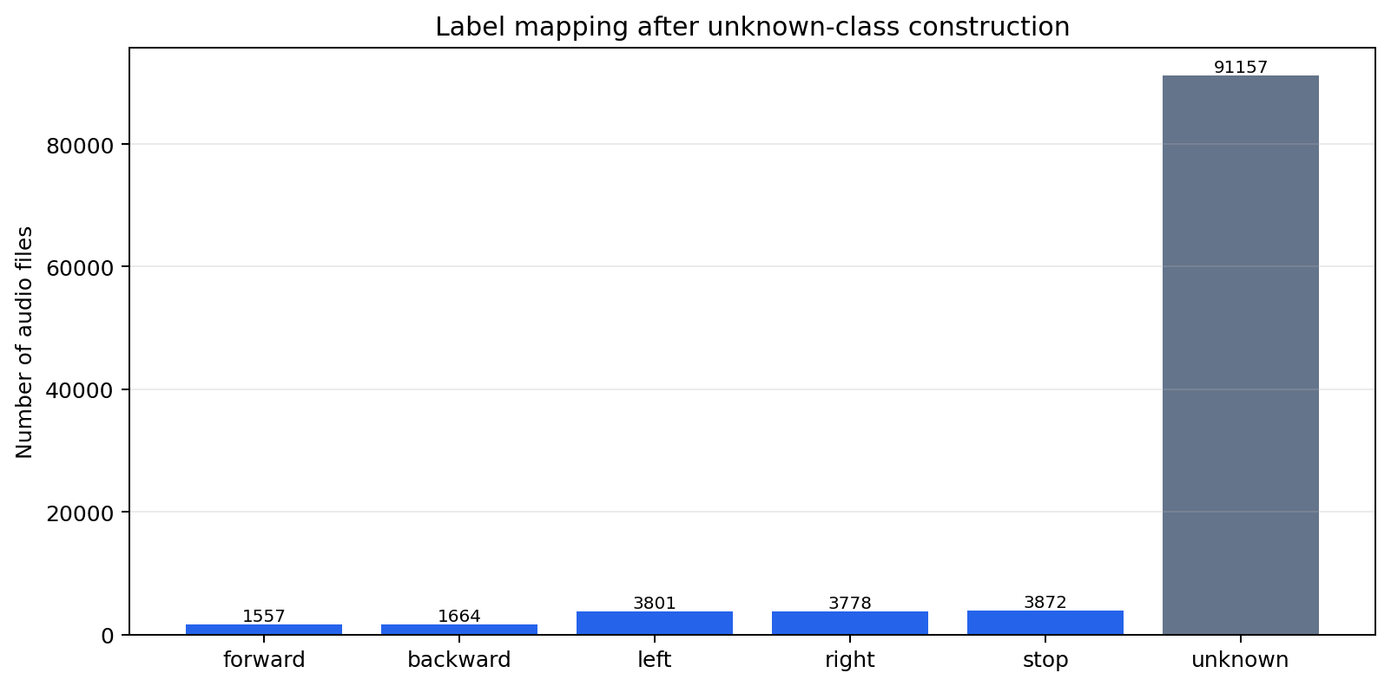

2.3.7. Dataset splitting
- The project uses the official Speech Commands train, validation, and test split.
- Training split: used to train the model.
- Validation split: used to select checkpoint and tune thresholds.
- Test split: used only for final reported results.
- The official split gives a fixed evaluation setting and reduces speaker leakage between training and testing.
- Figure: 07_dataset_split_distribution.png.
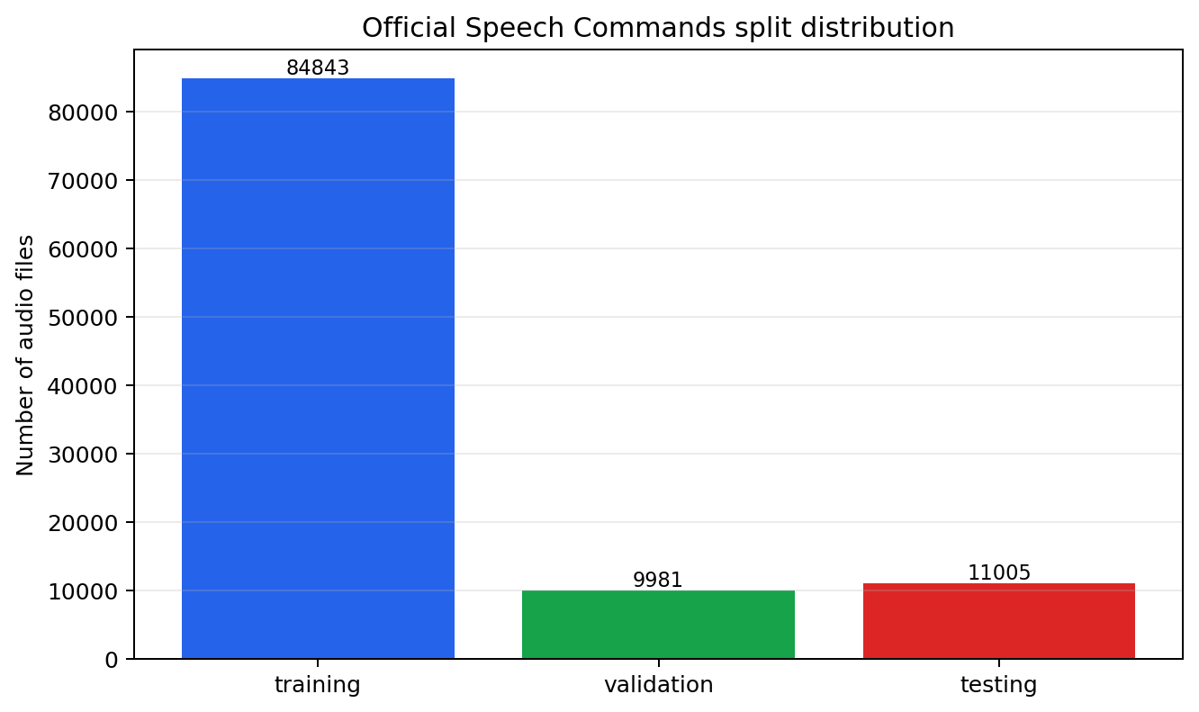

2.3.8. Training-only augmentation
- Augmentation is applied only to the training split.
- Validation and test data are not augmented.
- Add noise: simulate room noise or microphone noise.
- Time shift: simulate a command spoken earlier or later inside the recording window.
- Gain change: simulate louder or quieter speakers.
- Purpose: expose the model to more recording conditions during training.
- Figure: 08_training_augmentation_waveforms.png.
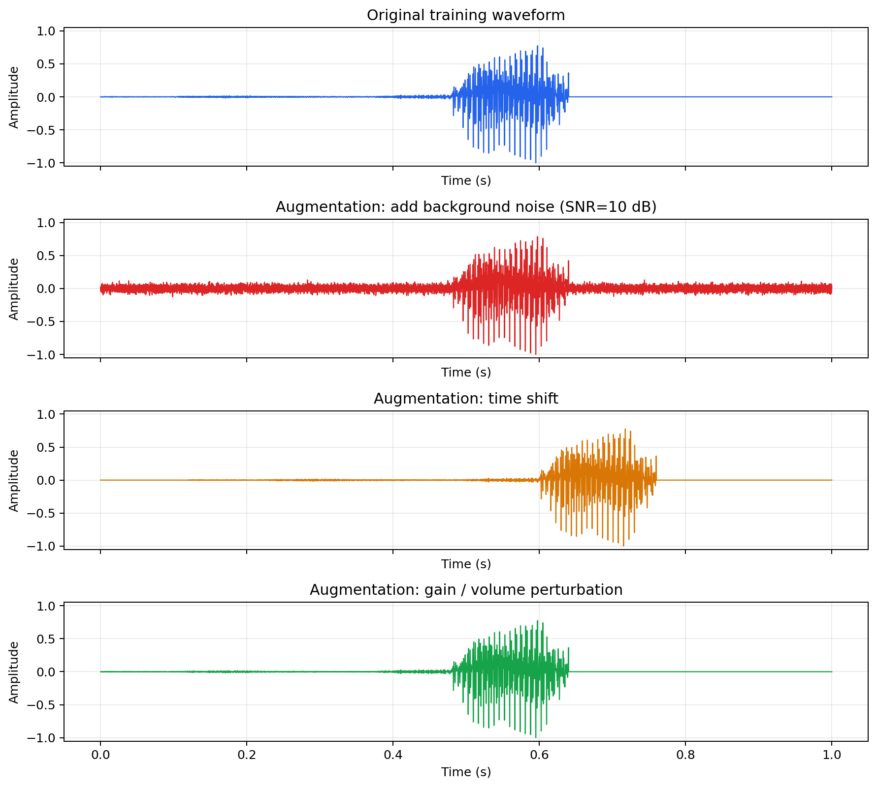

2.3.9. Final feature representation
- After waveform preparation, features are extracted for the model.
- Main model input: Log-Mel spectrogram with 64 Mel bands.
- MFCC is also shown because one baseline uses MFCC + CNN.
- Log-Mel keeps a clear time-frequency structure for CNN and CNN-GRU models.
- Figure: 09_final_model_input_features.png.
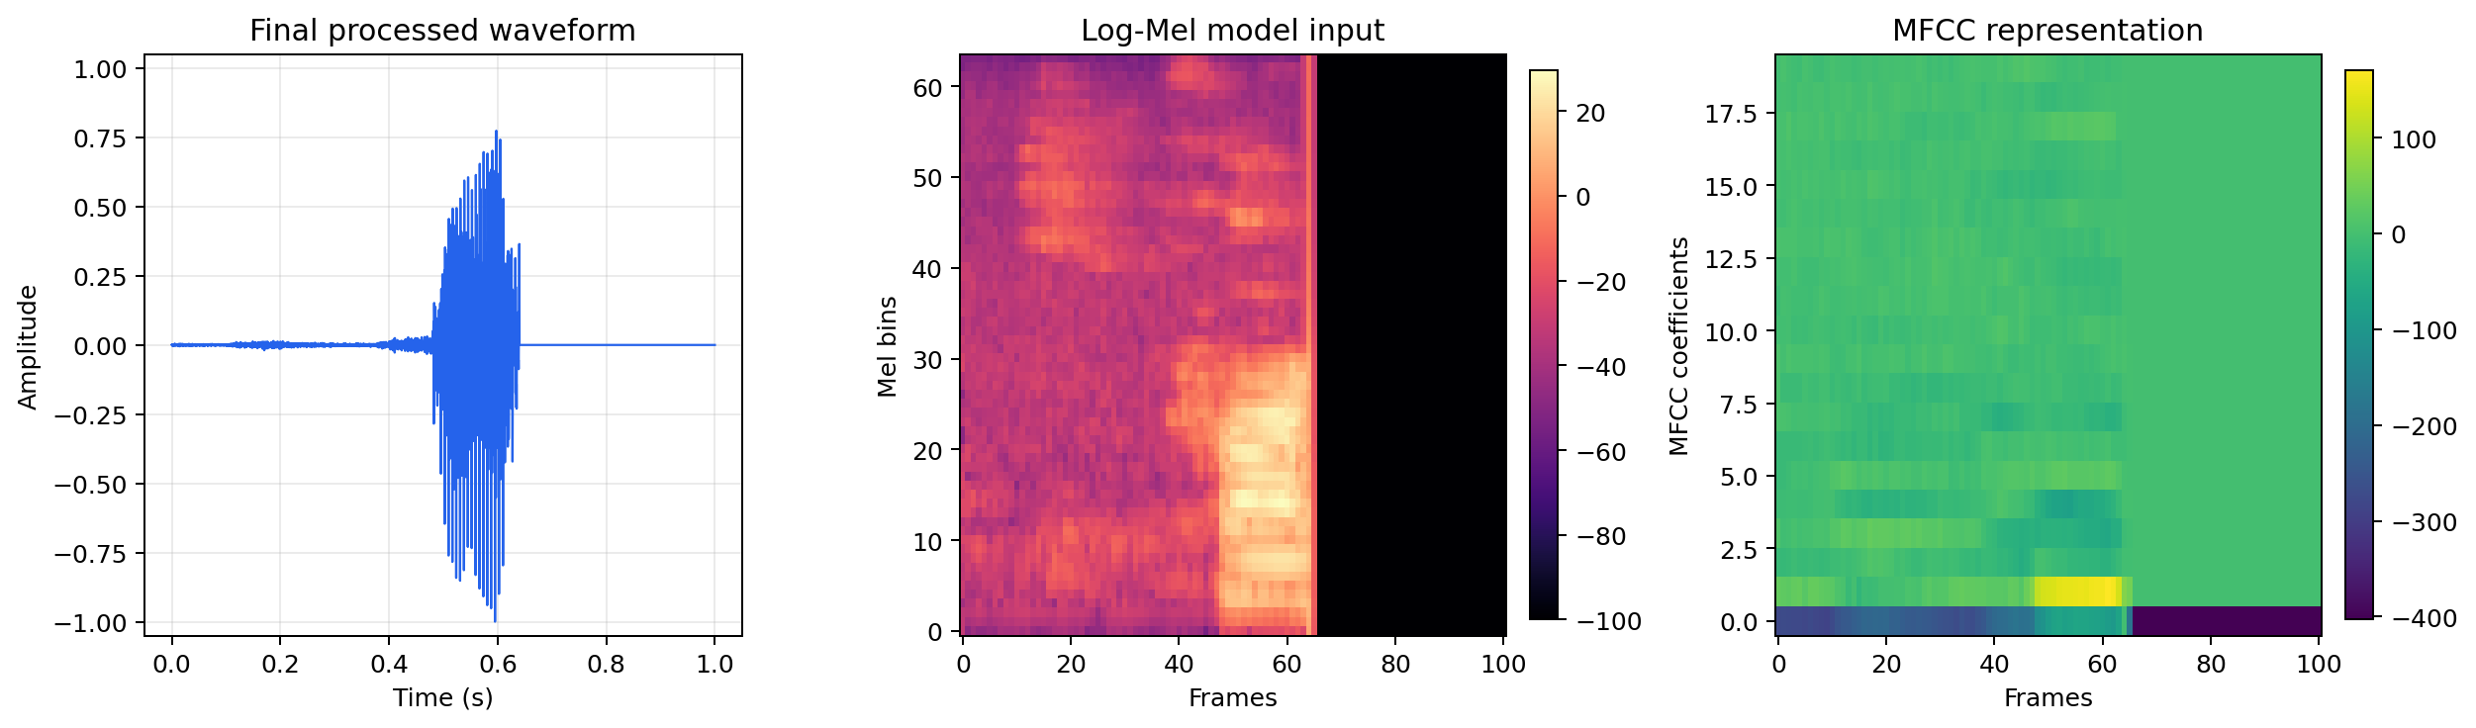
3.1. Proposed System Architecture and Workflow
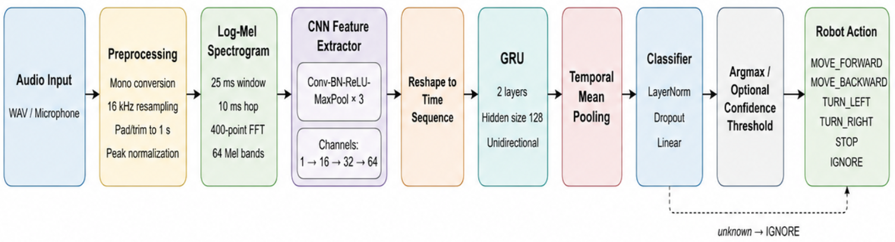

The proposed CRNN combines CNN for local time-frequency feature extraction and GRU for temporal sequence modeling. During model development, preprocessed audio from the training and validation sets is converted into Log-Mel spectrograms.
The model outputs logits, which are converted into probabilities using softmax, and argmax selects the predicted class.
The unknown class is mapped to IGNORE, while valid commands are mapped to the corresponding robot actions (MOVE_FORWARD, MOVE_BACKWARD, TURN_LEFT, TURN_RIGHT, STOP, or IGNORE)

Codex: Revised content for Section 3.1

Architecture
Text architecture diagram:
Audio Input
-> Data Preparation
-> mono conversion
-> resampling to 16 kHz
-> fixed-length 1-second window
-> optional speech alignment
-> noise handling
-> amplitude normalization
-> Feature Extraction
-> MFCC for MFCC-CNN baseline
-> Log-Mel spectrogram for CNN and CNN-GRU models
-> Command Recognition Model
-> MFCC + CNN baseline
-> Log-Mel + CNN baseline
-> Log-Mel + CNN-GRU selected model
-> Prediction Output
-> class label
-> confidence score
-> Safety Validation
-> confidence threshold
-> unknown-command rejection
-> allowed command check
-> command timeout
-> stop command priority
-> Action Mapping
-> forward = MOVE_FORWARD
-> backward = MOVE_BACKWARD
-> left = TURN_LEFT
-> right = TURN_RIGHT
-> stop = STOP
-> unknown = IGNORE
-> Wheelchair Navigation Simulator
-> update position
-> update direction
-> block movement at map boundary
-> log command history

Wake-word note:
- The current prototype is wake-word-aware at the safety and state validation level.
- Real OpenWakeWord detection is not integrated yet.
- The intended final architecture uses wake-word detection as an activation gate before command recognition.

Workflow
1. Audio input received from microphone or WAV file.
2. Audio converted to mono and resampled to 16 kHz.
3. Audio adjusted to a fixed 1-second command window.
4. Optional speech alignment centers the active speech part.
5. Noise handling and amplitude normalization prepare the waveform.
6. Feature extraction converts waveform into MFCC or Log-Mel representation.
7. The selected model predicts one of six labels: forward, backward, left, right, stop, unknown.
8. Softmax converts logits into class probabilities.
9. The highest probability becomes the raw predicted command.
10. Safety validation checks confidence, unknown class, allowed command list, timeout, and stop priority.
11. If the command is rejected or ignored, the action becomes IGNORE and the simulator does not move.
12. If the command is accepted, it is mapped to a wheelchair action.
13. The simulator updates wheelchair position and direction.
14. If movement reaches map boundary, the simulator blocks the movement and records the reason.
15. The app displays waveform, feature image, predicted label, confidence, safety decision, and action history.

